About the Armstrong Counseling Program

Welcome to the Armstrong Counseling Website!
We are here to serve and support you. Fort Bend ISD’s Guidance and Counseling Program is a comprehensive, developmental program based on the Texas state model. Professional school counselors are available on all Fort Bend ISD campuses to support the academic, career, personal, and social development of every student.

Meet the Counselor

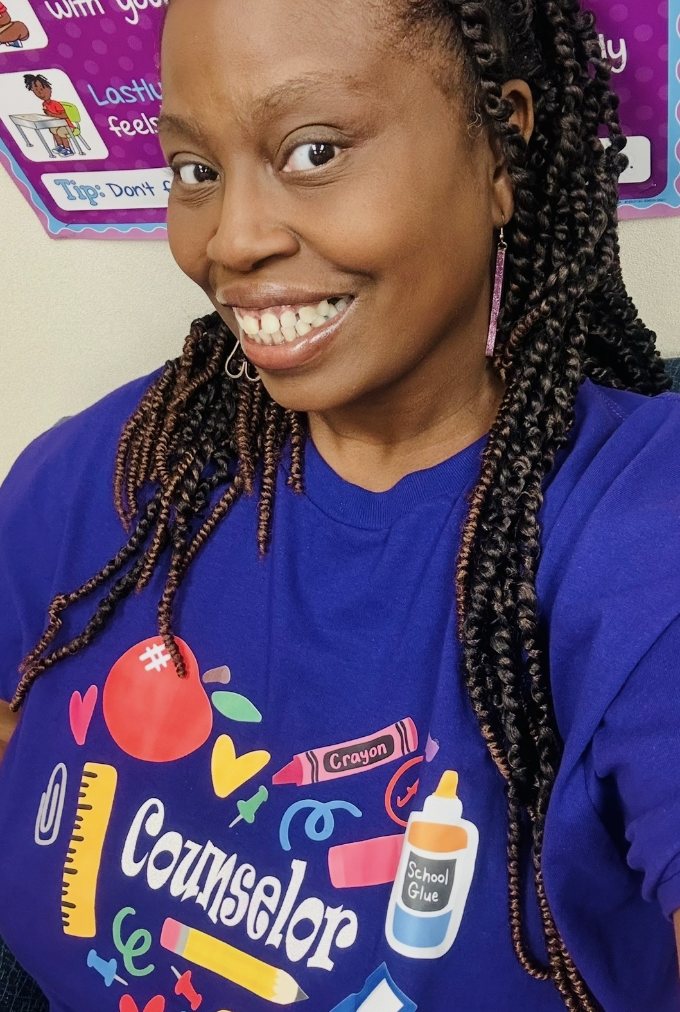
Hello, Gators! I am your friendly school counselor, Ms. Padgett. I have been an educator in elementary schools for over 20 years. Throughout my career, I have served in a variety of roles, including classroom teacher for grades Pre-K through 5th, Reading Interventionist, ESL Coordinator, and Testing Coordinator.
My diverse experience has thoroughly prepared me for my current role as a school counselor. I am passionate about supporting students and providing meaningful opportunities for growth, self-exploration, and positive social and emotional development.
In addition to counseling services, I strive to create engaging outlets for students by sponsoring programs such as girls’ and boys’ clubs, National Honor Society, Student Council, Cheer, Soccer, and a variety of educational field trips. My goal is to help every student feel supported, empowered, and encouraged to reach their full potential.
In my spare time, I enjoy spending time with my family and friends. I also love reading, decorating, and traveling. One of my personal goals is to visit as many countries as possible and learn from different cultures along the way.
I look forward to serving, guiding, and supporting your overall success in the years to come.

Our Counseling Program Includes:

🌟 Guidance Curriculum
Counselors provide classroom lessons and schoolwide activities that help students:
- Develop positive social skills
- Build problem-solving and decision-making skills
- Strengthening academic habits and goal-setting
- Learn strategies for managing emotions and behaviors

🧠 Social-Emotional Learning (SEL)
Social-Emotional Learning supports students in developing the skills needed for success in school and life. Through lessons, small groups, and individual support, students learn to:
- Identify and manage emotions
- Build positive relationships
- Demonstrate empathy and respect
- Make responsible choices
SEL is integrated throughout the school day and aligns with district and campus initiatives.

✅ Positive Behavioral Interventions and Supports (PBIS)
Armstrong implements PBIS to create a safe, positive, and predictable learning environment for all students. PBIS focuses on:
- Teaching and reinforcing positive behavior expectations
- Recognizing and rewarding appropriate behaviors
- Using data to guide behavior supports and interventions
- Providing consistent expectations across all school settings
PBIS helps students understand what is expected and supports positive choices both in and out of the classroom.

💬 Responsive Counseling Services
Responsive services are available to support students experiencing personal, social, emotional, or behavioral concerns that may impact learning. Services may include:
- Individual counseling
- Small group counseling
- Crisis intervention
- Collaboration with parents, teachers, and administrators

📘 Individual Planning
Counselors work with students to help them:
- Set academic and personal goals
- Monitor progress and growth
- Develop self-advocacy and responsibility
- Prepare for future educational and career pathways

🤝 System Support
Counselors collaborate with teachers, staff, parents, and community partners to:
- Promote student success and well-being
- Support schoolwide initiatives
- Provide staff consultation and resources
- Strengthen home–school connections

At Armstrong, our counseling program is dedicated to nurturing the whole child and ensuring every student feels supported, valued, and prepared for success.

📝 How to Refer a Student
Armstrong Counseling is committed to supporting students’ academic, social, emotional, and behavioral well-being. Students may be referred to the counseling office by parents/guardians, teachers, staff members, or through self-referral.

👩‍🏫 Staff Referrals
Teachers and staff may refer a student to the counselor when concerns arise related to:
- Academic performance or motivation
- Behavior or classroom concerns
- Social skills or peer relationships
- Emotional regulation or coping skills
- Attendance or engagement
Referral Process for Staff:
- Complete the campus counseling referral form.
- Submit the form to the counseling office.
- The counselor will review the referral and follow up as appropriate.

👨‍👩‍👧 Parent/Guardian Referrals
Parents or guardians who have concerns about their child’s well-being are encouraged to contact the school counselor directly.
Parents may request counseling support for concerns such as:
- Emotional or social challenges
- Behavioral concerns at school
- Family changes or stressors
- Academic concerns impacting emotional well-being

🎒 Student Self-Referrals
Students are always welcome to request to speak with a school counselor.
Students may:
- Ask their teacher for a pass to visit the counseling office
- Speak directly with a counselor
- Request a check-in when needed
Counselors strive to meet with students as soon as possible based on the urgency of the concern.

⏱ Urgent Concerns
If a student is experiencing an immediate crisis or safety concern, please notify the front office or an administrator immediately so the counselor can respond promptly.

Please note: School counseling services are short-term and solution-focused. Ongoing or intensive support may require referral to outside resources, in collaboration with families.

Counselor Contact Information

Flenisha.Padgett@fortbendisd.gov

281-634-9418

Emergency Resources
If you are in need of immediate assistance, please contact the following:

Crisis Hotline 1-866-970-4770

Youth Hotline 1-877-968-8454

Teen Hotline(s) 1-800-825-8336

Teen Hotline 713-529-8336

Emergencies 911

